Orbit chart

Connect to the sample superstore data and copy paste the model data set on the data canvas. Crate a cross join for the data using the edit join feature.

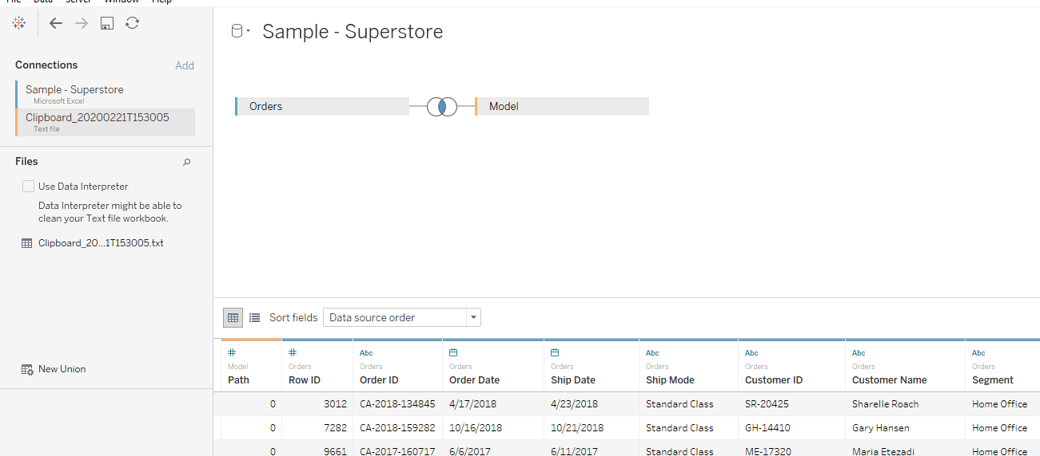

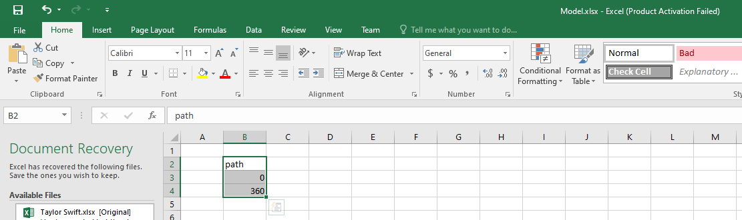

Go to the work sheet and create bin for the path measure by clicking on it and create bin.

In the marks card change to line and drag the path(bin) to the path in the marks card. Drag segment from dimensions to the column.

Create the following calculated fields

Index

INDEX()-1

X

SIN(RADIANS([index]))

Y

COS(RADIANS([index]))

Drag X to the columns shelf next to the Segment and Y to the Rows shelf and compute using path(bin).

Drag Segment to the colours Shelf.

Create following calculated fields

TC_sales

WINDOW_SUM(SUM([Sales])/2)

TC_totalsales

WINDOW_SUM(SUM([Sales]))/2

TC_percentage

[TC_sales]/[TC_totalsales]

Size

IF [index]/WINDOW_MAX([index])<[TC_percentage]

THEN 1

ELSE 0

END

Drag the size to the size in the marks card and compute using path(bin).

Edit the table calculations for the size in the marks card

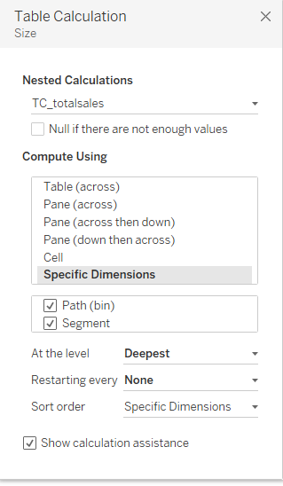

Create a calculated field

Zero

0

Drag Zero to the columns shelf next to Y. On the sum Zero on the marks card remove segment from the colors.

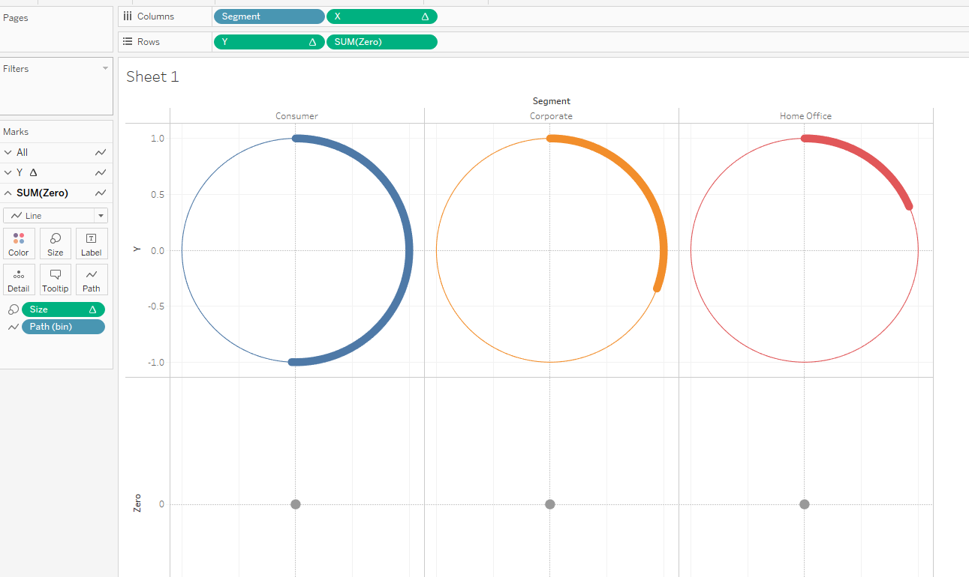

Click on sum(Zero) on the columns and dual axis and then synchronize the axes.

On the marks card click on Sum(zero) and the change from line to text.

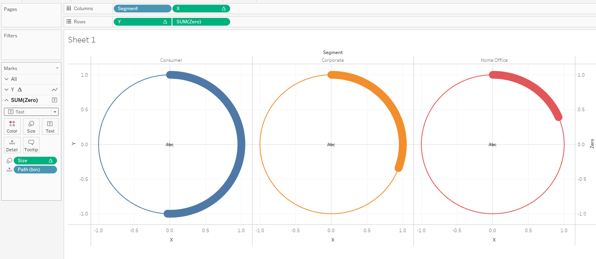

In the Sum(zero) in the marks card drag Segment, TC_sales and TC_percentage and format as desired.

The Final worksheet looks like this

